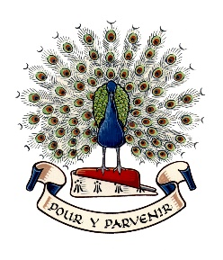
Lady Manners School

Election of Parent Governor

Nomination Form - January 2026

Nominee Name:

Nominee Contact Details:

Nominee Personal Statement (maximum 250 words)

I confirm that I am willing to stand for election as a Parent Governor and that I am not disqualified from holding office for any of the reasons set out in the qualifications and disqualifications sheet.

Nominee signature:

Date:

If you are proposing a candidate for nomination, please provide:

Proposer name and contact details:

Please return your nomination form to the school by 4pm on Thursday 22 January 2026. The form may be delivered by hand, sent to school with your child, sent by post marked for the attention of the Headteacher or sent electronically by email to governors@ladymanners.derbyshire.sch.uk,

