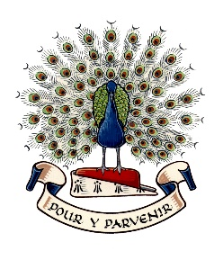Lady Manners School

Election of Parent Governor

Nomination Form - September 2025

|  |  |
| --- | --- |
| Name: |  |

|  |  |
| --- | --- |
| Address: |  |

I have a child at the school and do not work at the school for more than 500 hours in any consecutive 12-month period and am not an elected member of the Local Authority. I hereby nominate myself for election as a Parent Governor of the school. I understand that, if elected, I will have to provide a declaration of eligibility and 2 items of proof of identity.

A personal statement for inclusion in the voting paper is given overleaf.

|  |  |
| --- | --- |
| Signed: |  |

|  |  |
| --- | --- |
| Seconded by: (name) |  |

|  |  |
| --- | --- |
| Address: |  |

|  |  |
| --- | --- |
| Signature: |  |

*The seconder must be a parent of a student at the school.

|  |
| --- |
| **PERSONAL STATEMENT to include:**  **Why I am interested in being a school governor and what I can bring to the role:**  *(When completing this section, please include details of generic experience / knowledge / skills you have to offer. These could include professional expertise, community involvement, voluntary work etc)*  ***Candidates may also wish to include details as outlined in the nomination letter.*** |

Please return your nomination form to the school by **12.00 noon on Monday 13 October 2025.** The form may be sent electronically by email to [governors@ladymanners.derbyshire.sch.uk](mailto:governors@ladymanners.derbyshire.sch.uk), delivered by hand, sent to school with your child, or sent by post marked for the attention of the Headteacher.